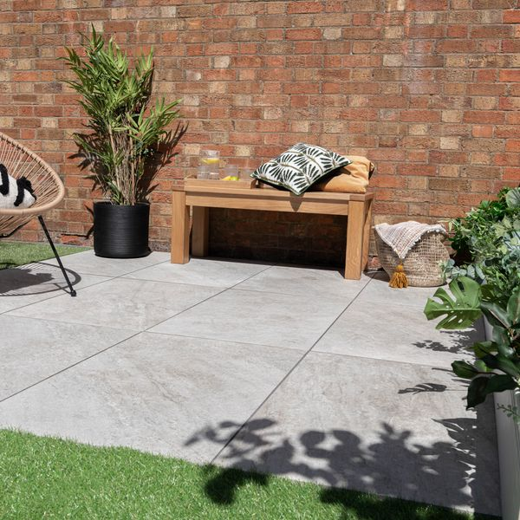**Icaria XL Blanco Porcelain Paving Slabs:**

## **Product Description**

Looking for a stylish, yet a functional paving option for your outside space? Our Icaria Plus Blanco Porcelain Paving Slabs feature a quartzite effect design with textured directional veining and a pale ivory hue. Durable, hardwearing and easy to clean, these natural-looking tiles are perfectly suited for the outdoors with a 20mm thick porcelain construction and a matt, anti-slip finish.

**What’s special about these tiles?**

> Quartzite effect design

> Durable and hardwearing

> Anti-slip surface

> Long lasting and frost-proof

**The perfect finishing touch**

For that perfect finish around your patio space, line the edges with our stylish new [20mm Paving Slab Trims!](https://www.wallsandfloors.co.uk/20mm-paving-slab-trims) Choose the colour that best matches your style!

## **Product INFO**

* Product ID: 801480
* Tiles Per SQM: 1.8518518518519
* Sale by: Per SQM
* Size: 600x900x20mm
* Weight: 21.43 KG
* Material Type: Porcelain
* Finish: Matt
* Colour: White
* Suitability: Floors, Walls
* Area Of Usage: External
* Grade: 4
* Rectified Edge: Yes
* Underfloor Heating: No
* Anti Slip Grade: R11 / 35 Degrees
* Document: [Cleaning & Protection Guide](https://m2.wallsandfloors.co.uk/media/amasty/amfile/attach/v6zDQ2bNO72eOYbIuSFeTd6kQ5FyNJtj.pdf),[20mm Installation Guide](https://m2.wallsandfloors.co.uk/media/amasty/amfile/attach/20mm-installation-guide_4.pdf)
* Thickness (mm): 20